**TEAM-4**

**OUTPUT SCREENSHOTS:**

**1.Enter temperature in Celsius and convert it to Fahrenheit**

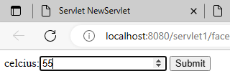

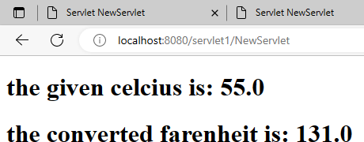

**2. Create web application to display a list of famous people. Allow user to click on a person to view their biography.**

